# Steps to convert a microservice into Spring Cloud Config Client

1. **Step 01**: Add the following Dependency.  
   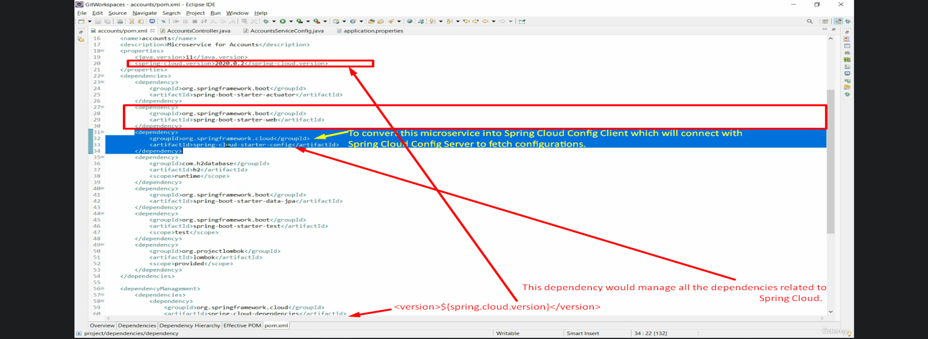

Adding the above dependency will convert automatically a spring boot microservice into Spring Cloud Config Client.

1. **Step 02**:   
   Configure in application.properties about
   1. From which Spring Cloud Config Server to bring config.
   2. For which environment and which microservice, the file property file is to be fetched.

